Balancing Chemical Equations
Remember that with a formula you are shown how many of each atom is in one molecule of a compound
The subscript is the name given to the number directly to the right of the element. It tells you how many atoms there are of that particular element. If there isn't a subscript, that means there is only one atom. For example, let's look at the water molecule.
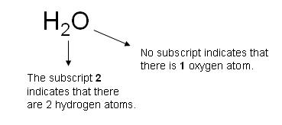

Reactants=the chemicals at the start of a chemical reaction.
Products=the chemicals made in a chemical reaction.
The reactants are on one side of the arrow.
Products are on the other side of the arrow.
A balanced chemical equation has equal numbers of all elements on each side of an equation.
Some equations are already balanced for example. Carbon burning in oxygen.
Reactants products
Carbon + oxygen gas------carbon dioxide
C + O₂ ----------- CO₂
1 carbon 1 carbon
2 oxygen 2 oxygen
Some do not
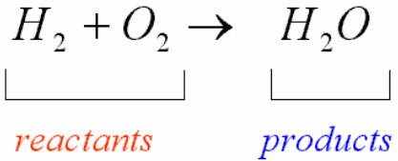
2 hydrogen 2 hydrogen
2 oxygen 1 oxygen
Notice there are more oxygens on the reactants side than on the products side.
To balance this equation we will need the following
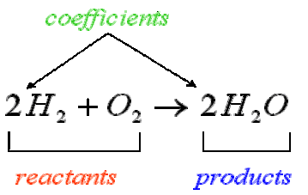
4 hydrogen 4 hydrogen
2 oxygen 2 oxygen
The coefficient is the number that goes in front of a chemical formula

